Jonathan Oen

A14547654

**ECE 115 module 1 report**

Picture of part 1 and part 2 assembled

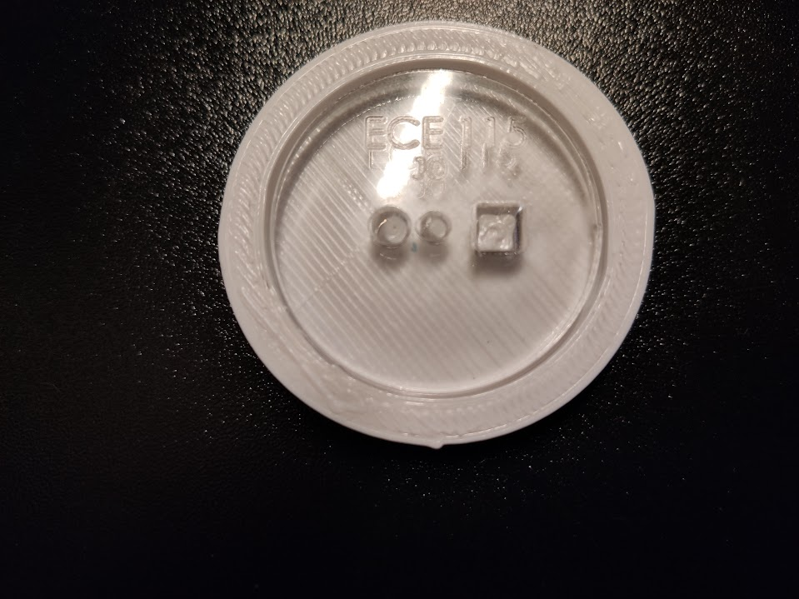

Picture with measurements

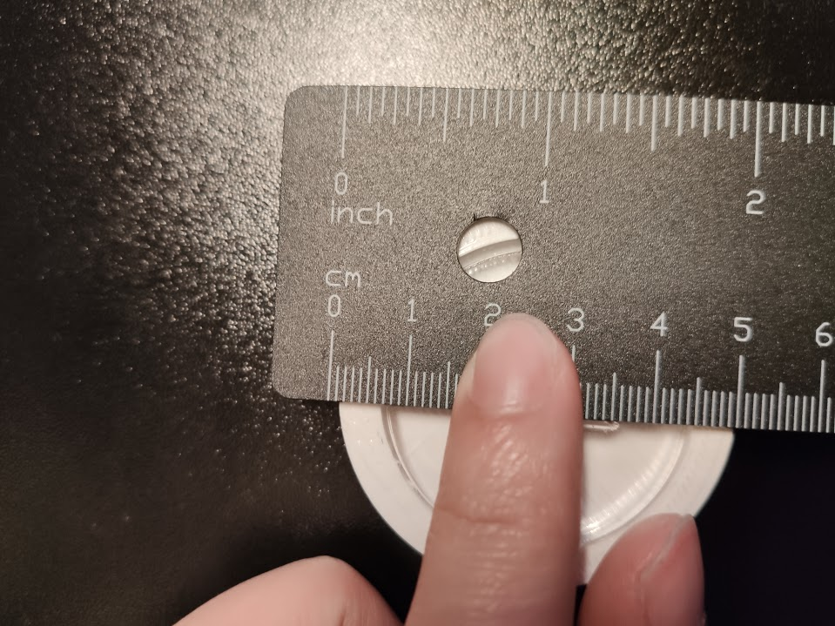

Expected Measurements

Circumference: 50mm

Height:10mm

Measured Measurements

Circumference:52 mm

Height:11mm

The actual measurements were slightly bigger than the desired measurements in the CAD because when the 3d printer prints, the material expands afterwards.

**1.3.2.b**

See pdf and stl file for parts

1.3.3)

Block diag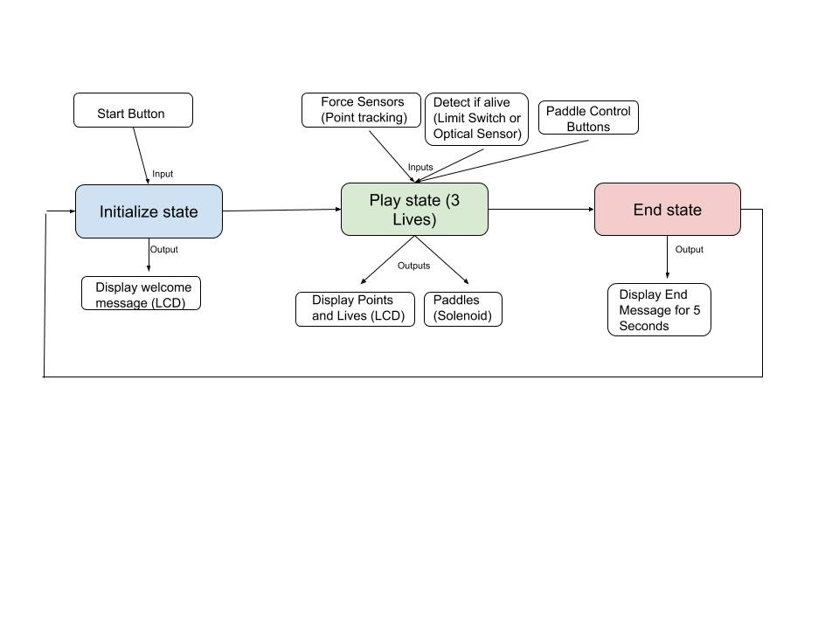

1.3.4.a)

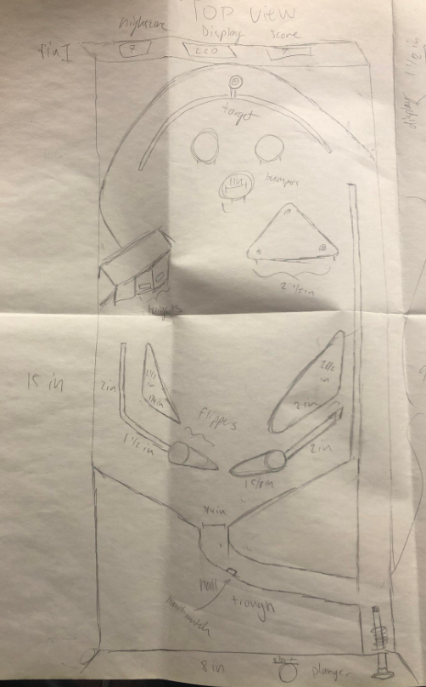

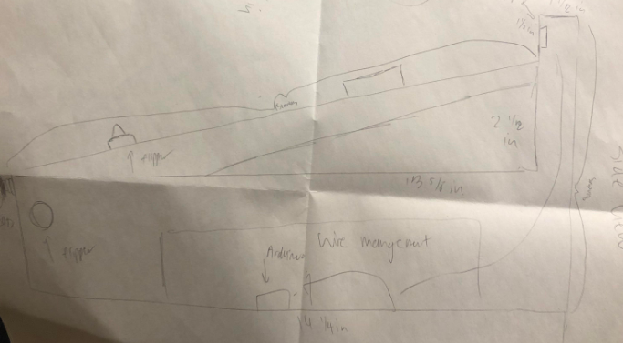

For the solenoid of each flipper, we will make a bracket to support the motor up and not be hanging from a few screws.

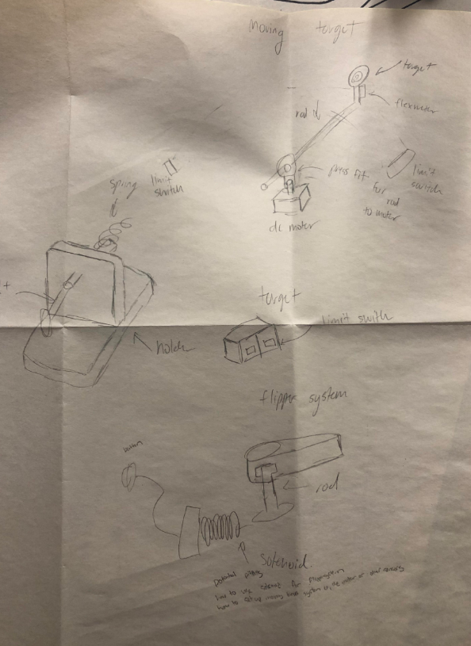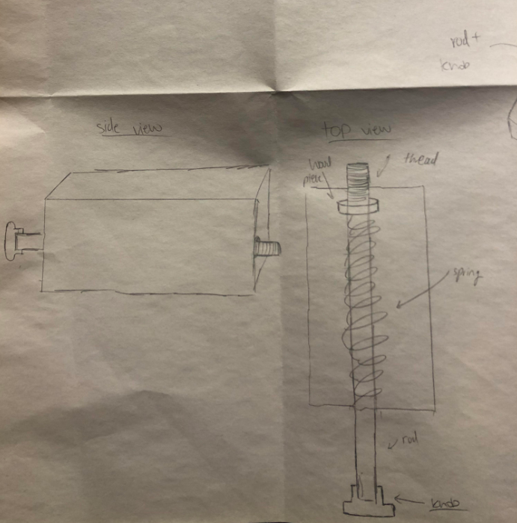

1.3.5.a)

See attached files for more details

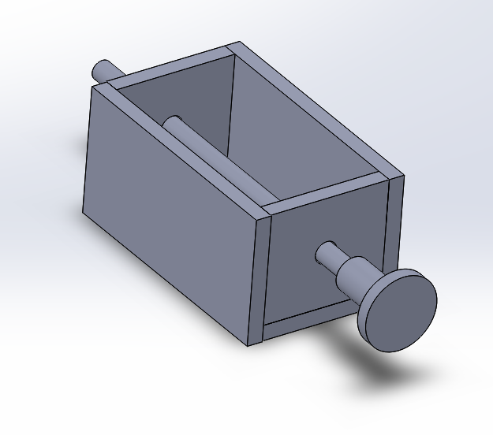

11.3.5.b)

What we would like to change about our design is a shorter and skinnier box that would allow for the user to pull back further and stabilize the ball.

1.3.5.c)

Test Matrix

|  |  |  |  |  |  |
| --- | --- | --- | --- | --- | --- |
| Specification number | Specification description | Test to perform | Relevant requirement | Specification (Units) | Measured Value (Units |
| 1.1 | Ball push distance | Fire the ball of a ramp | 1 | Must go the length of the playfield or 15 inches | 4 inches |

1.3.5.d)

Potential notes for redesign:

The holder box was too short which didn’t allow the user to pull the rod back far enough to fire the ball the required distance of the ramp. Our idea to fix this is to shorten the box to allow more the user to pull back further and fire the ball a further distance. We were also thinking about making the holder skinnier and to extend it to be able to hold the ball and make it easier to test and integrate into the larger system later.